**Case Study – Creation of VM and Github Actions**

**Steps:**

1. Login with user credentials into Microsoft Azure and Click on Virtual Machine
2. Select the following options on the first page.

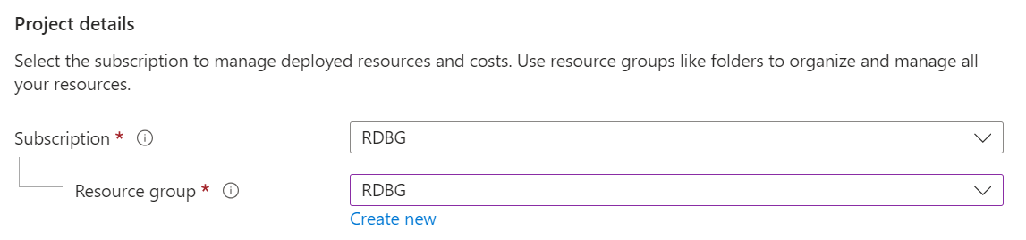

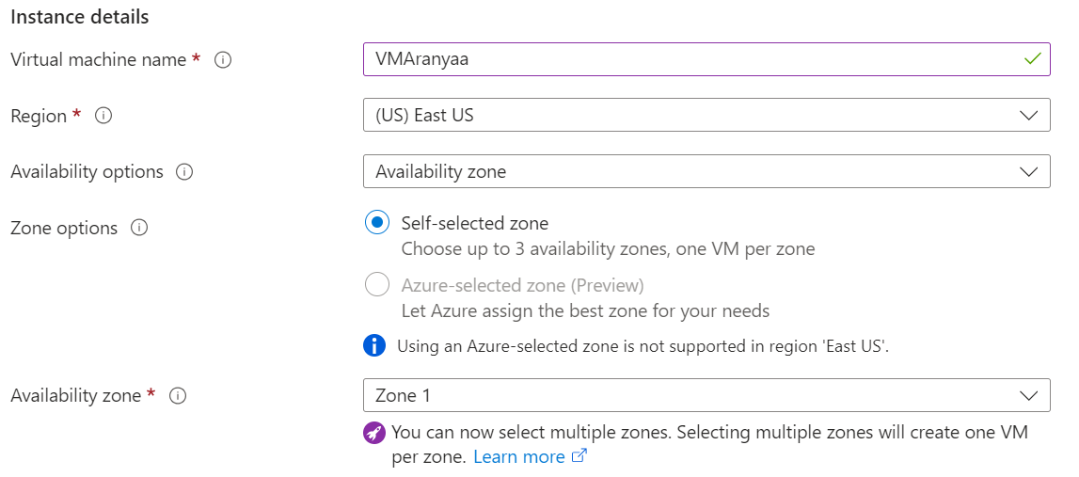

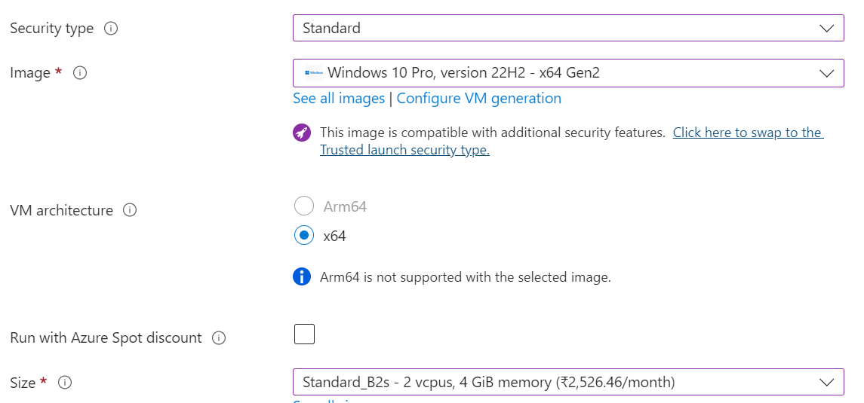

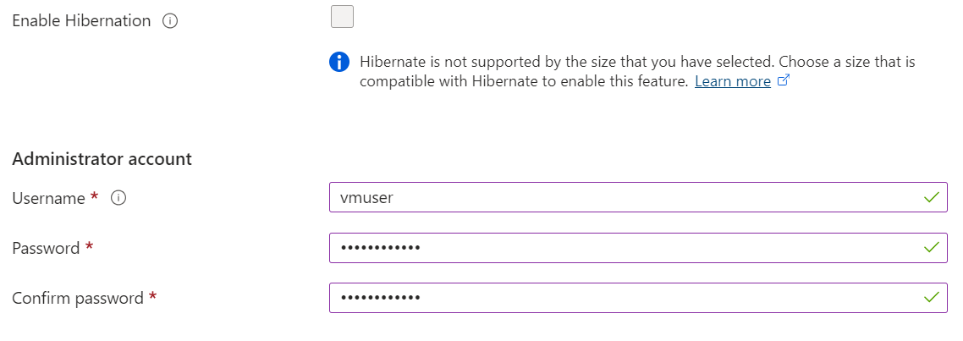

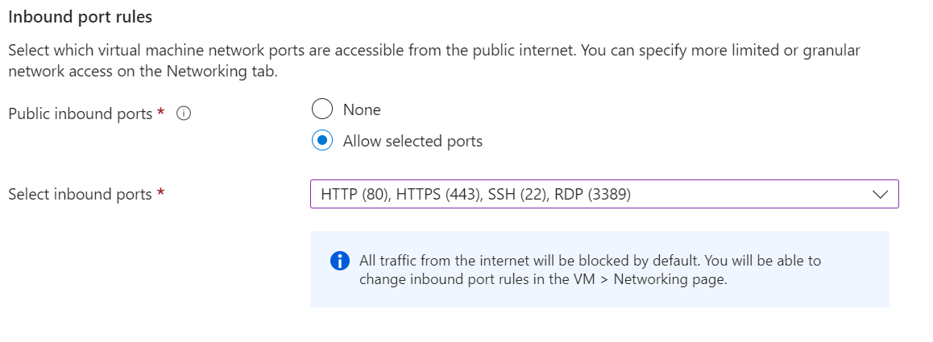

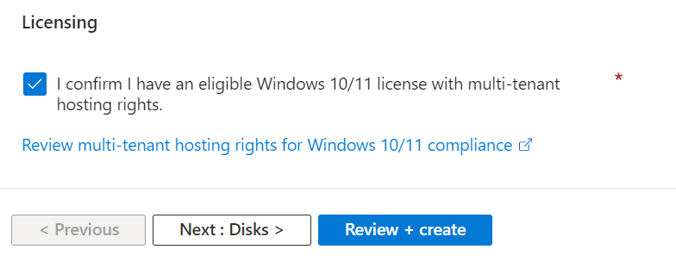

1. Click on “Next : Disks >” button
2. Select the following options.

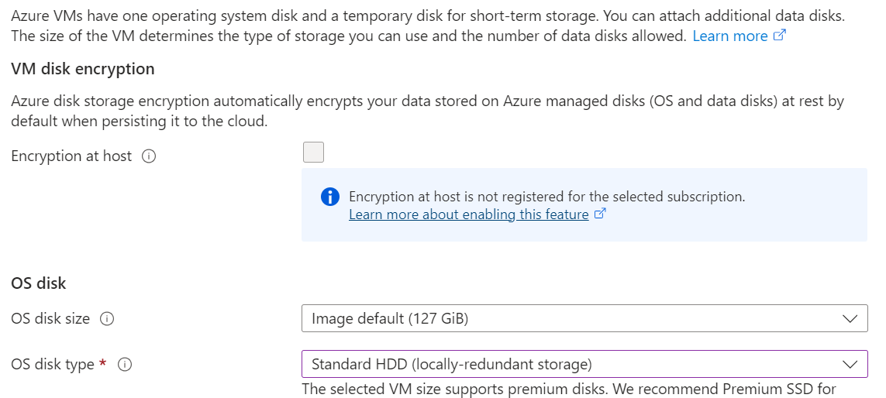



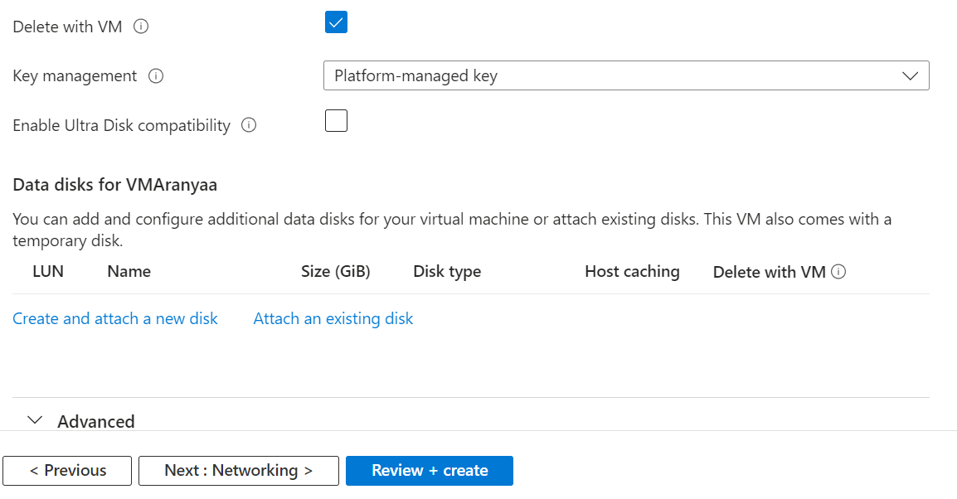

1. Click on “Next: Networking ”.
2. Select the following in the new page
3. Click on Create new under Virtual network and put in the following details and click ok.

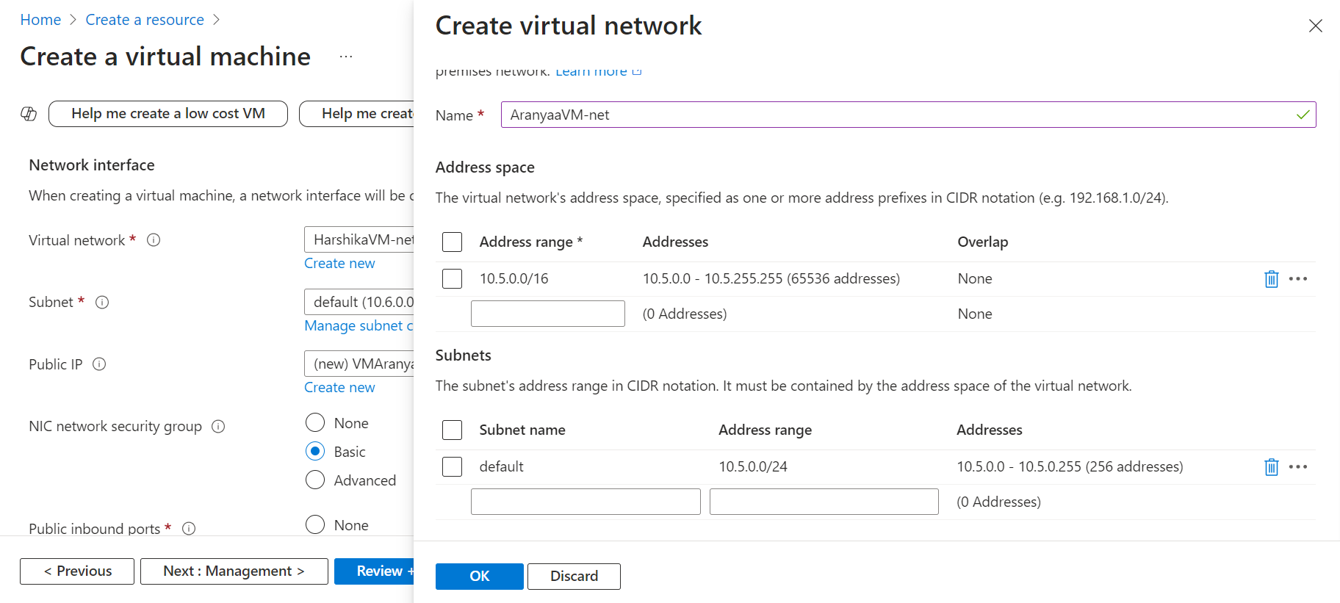

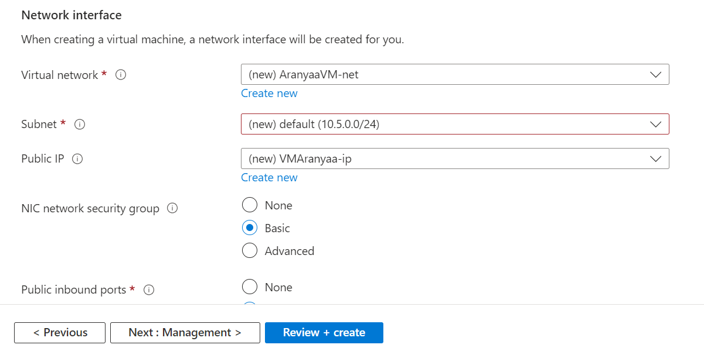

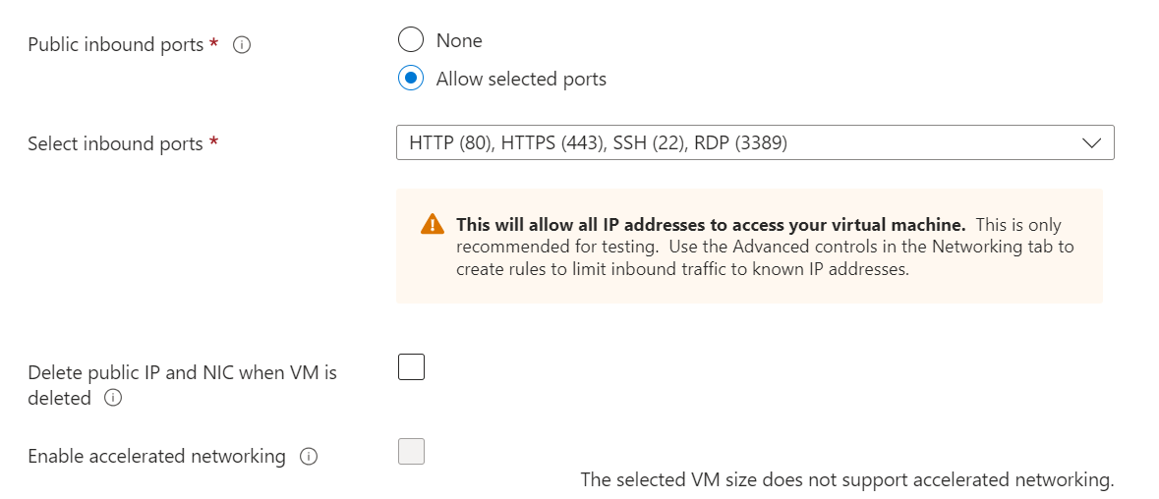

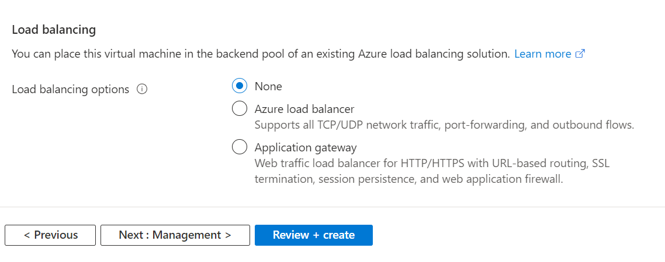

1. Click on Review and Create.
2. Validation should pass. And then click on create.

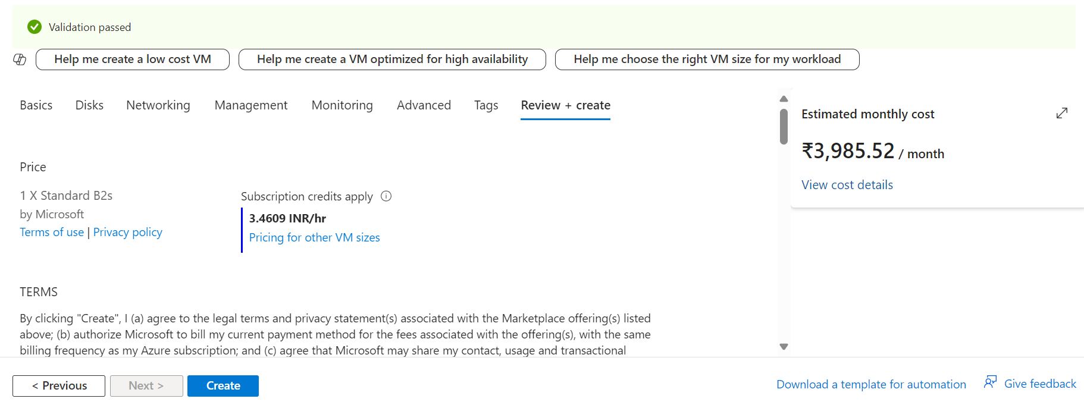

1. Deployment initialization starts and goes into deployment process.

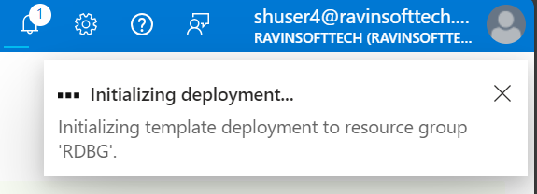

1. Deployment is then complete. Click on Go to resource.

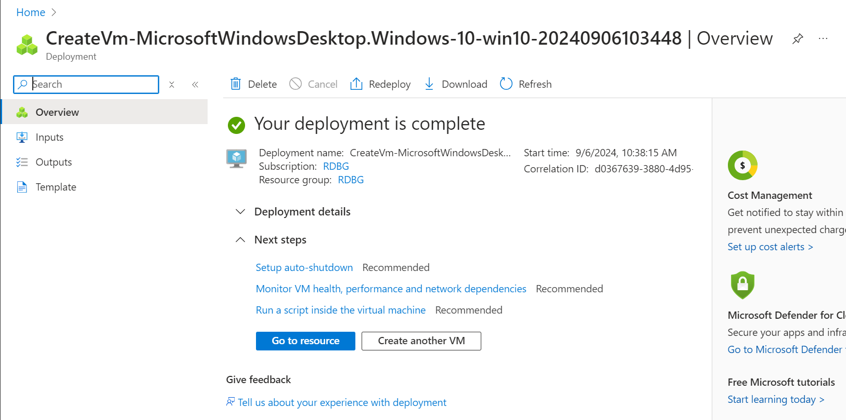

1. Click on Connect



1. Scroll and download the RPD File

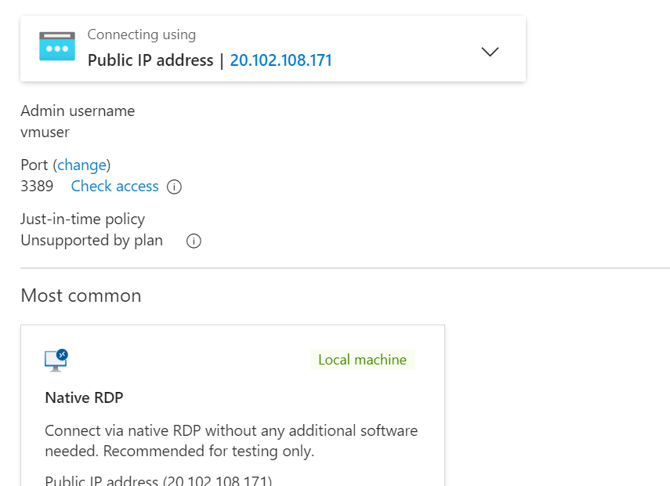

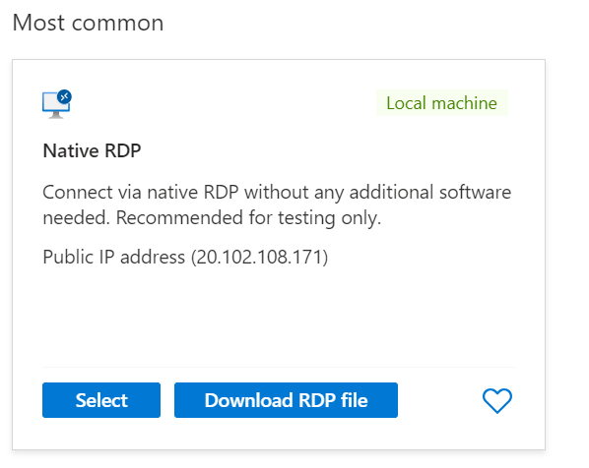

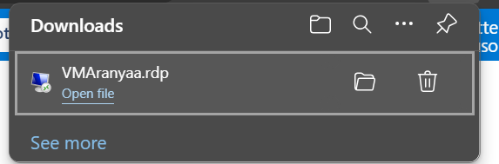

1. Open file and enter VM credentials.

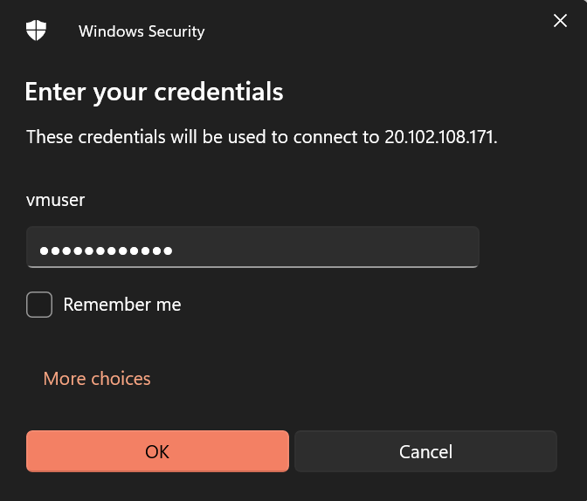

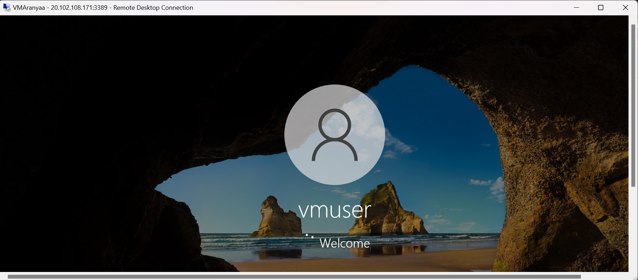

1. Create a github repository.

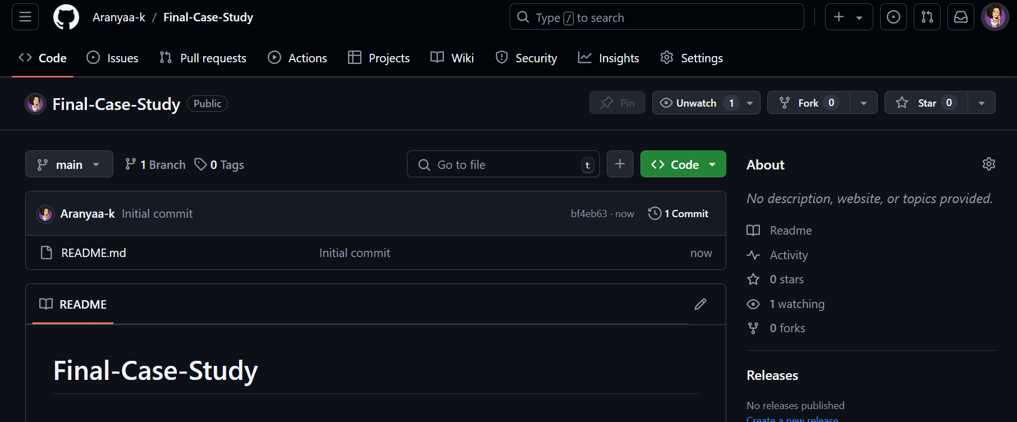

1. Add the java code for calculator.

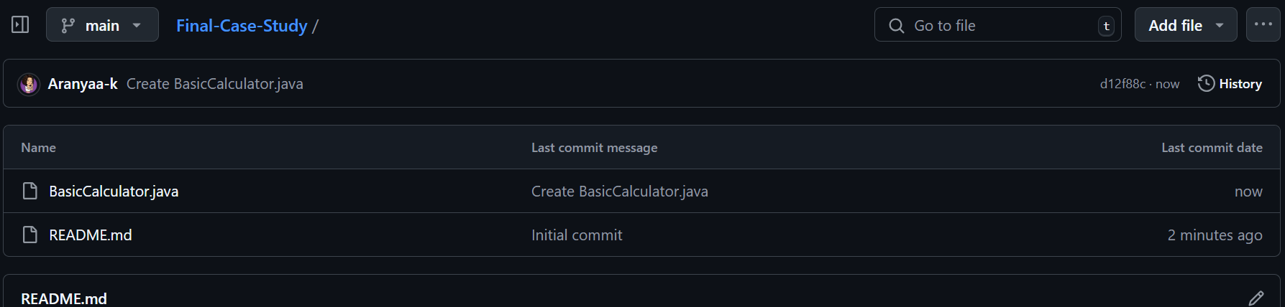

public class BasicCalculator {

private double number1;

private double number2;

// Getter for number1

public double getNumber1() {

return number1;

}

// Setter for number1

public void setNumber1(double number1) {

this.number1 = number1;

}

// Getter for number2

public double getNumber2() {

return number2;

}

// Setter for number2

public void setNumber2(double number2) {

this.number2 = number2;

}

// Method to add the two numbers

public double add() {

return number1 + number2;

}

// Method to subtract the two numbers

public double subtract() {

return number1 - number2;

}

// Method to multiply the two numbers

public double multiply() {

return number1 * number2;

}

// Method to divide the two numbers

public double divide() {

if (number2 != 0) {

return number1 / number2;

} else {

throw new ArithmeticException("Division by zero is not allowed.");

}

}

public static void main(String[] args) {

Calculator calc = new Calculator();

calc.setNumber1(10);

calc.setNumber2(5);

System.out.println("Answers:");

System.out.println("Addition: " + calc.add());

System.out.println("Subtraction: " + calc.subtract());

System.out.println("Multiplication: " + calc.multiply());

System.out.println("Division: " + calc.divide());

}

}

1. Click on Actions and choose java with maven and configure the yaml file.

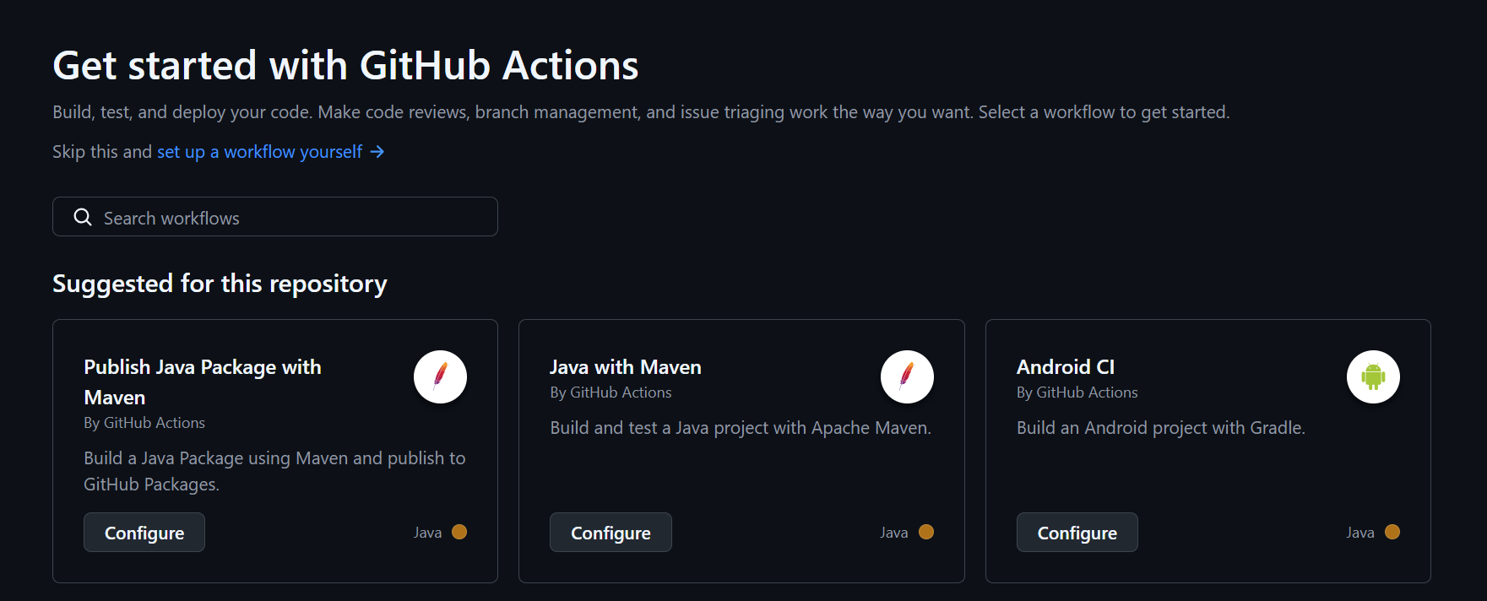

1. Write the code with maven.yaml and commit the changes

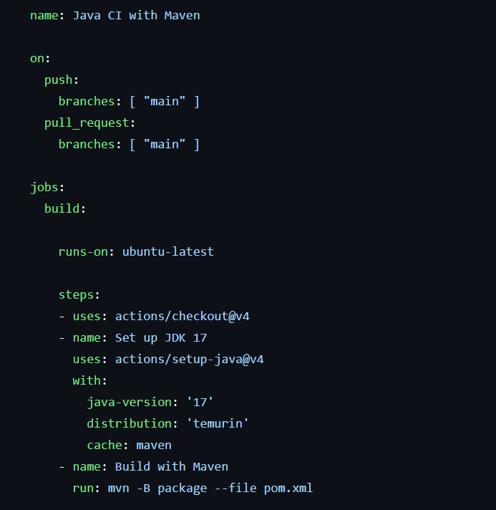

1. Make a change in the code file to notice the workflow in action and commit the new changes.



1. The workflow should be successful after the new update.



